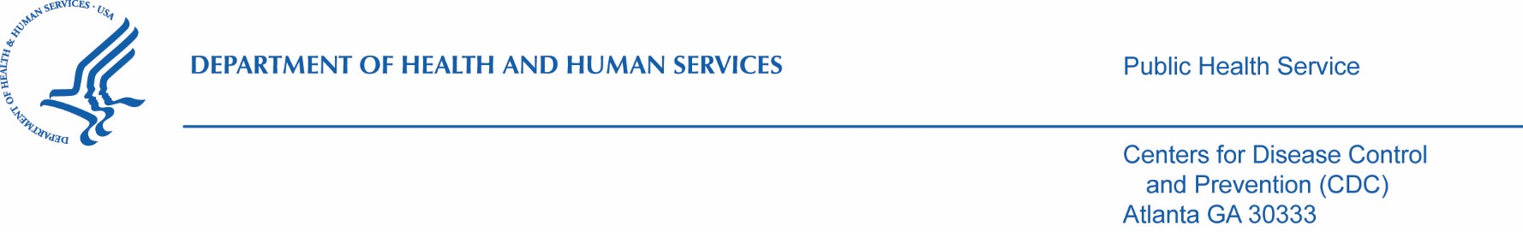 September 24, 2021

Elizabeth Brehm

Siri & Glimstad

200 Park Avenue

17th Floor

New York, NY 10166

Via email: foia@sirillp.com

Dear Ms. Brehm:

This letter is regarding your Centers for Disease Control and Prevention and Agency for Toxic Substances and Disease Registry (CDC/ATSDR) Freedom of Information Act (FOIA) request of February 2, 2021, assigned #21-00597-FOIA, for (see attached (see attached request).

We located 1999 pages of responsive records (1427 pages withheld in full, 199 pages disclosed in part, 367 pages released in full, 6 pages referred to HHS). After a careful review of these pages, some information was withheld from release pursuant to 5 U.S.C. §552 Exemption 4, 5, and 6.

<https://centersfordiseasecontrol.sharefile.com/d-sfd017a0b81a3454a8a0d03813bdae350> (link expires in 180 days)

**EXEMPTION 4**

Exemption 4 protects trade secrets and commercial or financial information obtained from a person that is privileged or confidential. The information withheld is commercial or financial information, such as commercial analysis, and we have determined that the individual/s to whom this information pertains have a substantial commercial or financial interest in withholding it.

**EXEMPTION 5**

Exemption 5 protects inter-agency or intra-agency memorandums or letters which would not be available by law to a party other than an agency in litigation with the agency. Exemption 5 therefore incorporates the privileges that protect materials from discovery in litigation, including the deliberative process, attorney work-product, and attorney-client privileges. Information withheld under this exemption was protected under the deliberative process privilege. The deliberative process privilege protects the decision-making process of government agencies. The deliberative process privilege protects materials that are both predecisional and deliberative. The materials that have been withheld under the deliberative process privilege of Exemption 5 are both predecisional and deliberative, and do not contain or represent formal or informal agency policies or decisions. Examples of information withheld include preliminary data.

**EXEMPTION 6**

Exemption 6 protects information in personnel and medical files and similar files when disclosure would constitute a clearly unwarranted invasion of personal privacy. The information that has been withheld under Exemption 6 consists of personal information, such as cell phone number and conference call information. We have determined that the individual(s) to whom this information pertains has a substantial privacy interest in withholding it.

We are referring 6 pages to the Department of Health and Human Services, Freedom of Information Act Office for further processing and direct reply to you since these records fall under their jurisdiction.

You may contact our FOIA Public Liaison at 770-488-6277 for any further assistance and to discuss any aspect of your request. Additionally, you may contact the Office of Government Information Services (OGIS) at the National Archives and Records Administration to inquire about the FOIA mediation services they offer. The contact information for OGIS is as follows: Office of Government Information Services, National Archives and Records Administration, 8601 Adelphi Road-OGIS, College Park, Maryland 20740-6001, e-mail at ogis@nara.gov; telephone at 202-741-5770; toll free at 1-877-684-6448; or facsimile at 202-741-5769.

If you are not satisfied with the response to this request, you may administratively appeal to [the Deputy Agency Chief FOIA Officer, Office of the Assistant Secretary for Public Affairs, U.S. Department of Health and Human Services, via the online portal at https://requests.publiclink.hhs.gov/App/Index.aspx.](mailto:FOIARequest@psc.hhs.gov) Your appeal must be electronically transmitted by December 24, 2021.

Sincerely,

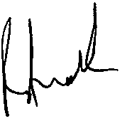

Roger Andoh

CDC/ATSDR FOIA Officer

Office of the Chief Operating Officer

(770) 488-6399

Fax: (404) 235-1852

Enclosures

21-00597-FOIA